**Task 2 : Phishing Emails**

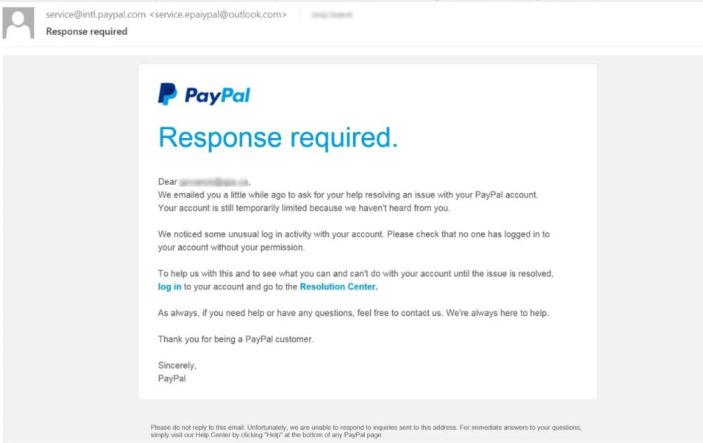Below is an example I have taken from Phishing.org which shows a “Response Required” email by PayPal.

PHISHING TRAITS

1. The email is an urgent/response tactic related email which requires for the receiver’s attention at the earliest.
2. Upon checking the sender’s email in a online header checker( DNS Checker) it is found that the email is flagged and has been reported by many users to be a suspicious email address.
3. The links in the email are not matching with the links that is shown in the hovering method.